BODY SYSTEMS

Multicellular organism: an organism that is made up of many different cells.

• In these organisms, cells group together to perform tasks.

Tissue: have cells that have a similar structure and appearance

• In the human body there are tissues such as muscle tissue, nerve tissue and epithelial tissue, such as skin.

Organ: made up of different tissues that work together.

• An organ usually has layers of different tissue.

e.g. The brain, heart and stomach are examples of organs.

Body system: a group of organs working together to perform a particular function.

e.g. Circulatory system is made up of the heart, arteries and veins.

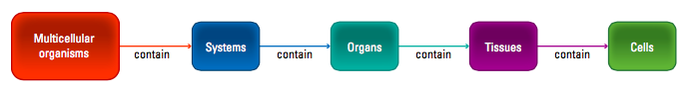

Tissues
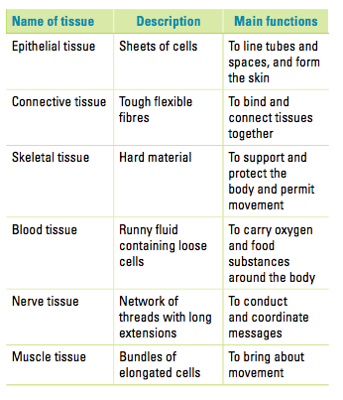
Systems

